The Implementation of Land Use Condition Change via ‘Fastrack’ for Land with No Specific Use Condition (NIL)

Syaidatul Amira, Siti Radiaton Adawiyah, Maryanti Raid, Wan Ibrisam Fikry Wan Ismail, Aminah Mohsin, Abd Halim Hamzah
Faculty Built and Environment, University Technology Malaysia

Abstract

Implementing land use condition change via ‘fast track’ for land with no specific use condition (NIL) is an initiative by the State Authority carried out across all District Land Offices in Johor, to reduce the burden on landowners in paying land taxes. Various issues have been examined concerning the implementation of the ‘fast track’ land use condition change process when there is no specific land use condition (NIL). Among the issues are how the ‘fast track’ land use condition change process is implemented and its effectiveness. Therefore, this study aims to identify the ‘fast track’ land use condition change process implemented in Johor and examine the effectiveness of the ‘fast track’ process when there is no specific land use condition (NIL). The Pontian District Land Office was selected as the study areas, focusing on its role in implementing the ‘fast track’ process. A qualitative research design was adopted, employing content analysis, descriptive analysis, and SWOT analysis based on data obtained from interview responses. The findings revealed several strengths and opportunities, as well as weaknesses and threats, in the implementation of the ‘fast track’ process, ultimately supporting its effectiveness. Based on the analysis, several recommendations are proposed. It is hoped that this study will offer valuable insights to relevant stakeholders and contribute to further improvements in the implementation of the ‘fast track’ land use condition change, particularly in cases involving land with no specific use condition (NIL).
Keywords: ‘fast track’ process, land use change, NIL condition, effectiveness
Introduction

In this era of globalisation, the administration and development of real estate in Malaysia have grown rapidly. This growth aligns with Malaysia’s aspiration to become a developed nation, necessitating realistic, organised, and well-planned development in line with national progress. According to the National Land Code 1965, development refers to changes that deviate from the original use or conditions approved by the State Authority. Such changes may involve several aspects, including interest restrictions, express conditions, and land categories. The pace of ongoing development highlights the need for more progressive reforms in land administration. Additionally, any proposed development must comply with the designated land category and express land use conditions to facilitate a smoother ad more efficient development process.

According to Section 124 of the National Land Code 1965, landowners who wish to develop their land must ensure that the proposed land use does not violate the designated land category, express conditions, implied conditions, or interest restrictions stipulated in the land title. If the exiting land category differs from the intended use, the landowner is required to apply for changes to the land use conditions, land category, and interest restrictions. Landowners must apply for a change in express land use conditions, and the land tax payable will be adjusted based on the new express land use conditions.

According to Section 5 of the National Land Code 1965 (NLC), land tax is defined as the annual amount payable to the State Authority, and any payment or arrears due must be collected as rent or land revenue. Land tax is an annual tax that must be paid by landowners once a year between January 1 and May 31, and late payments will incur penalties (Abu Seman, 2007). The State Authority must ensure that all landowners settle their land tax payments to reduce arrears. Additionally, the role of the District Land Office in addressing this issue is crucial and requires proactive measures to resolve the problem so that the burden on landowners and violations of express land use conditions can be reduced. The firmness and efficiency of the District Land Office provide significant benefits, as it facilitates all stakeholders, particularly those affected in the case study area.

According to the 2018 Auditor General’s Report, the Johor Bahru District Land Office recorded a significant increase in land tax arrears, amounting to RM 59.87 million, reflecting a 22.1% rise in 2018. Of this increase, applications for land use condition change contributed 10% to the total arrears. The economic downturn was identified as a major factor contributing to landowners’ difficulties in fulfilling land tax obligations. This burden was also felt by landowners holding titles with NIL express conditions, especially after the land tax increase in 2020 for such title (Land Tax Implementation Briefing, PTG Johor).

The impact of this burden has led many landowners to default on land tax payments, reducing state’s revenue collection (Nur Maizatul Akmal, 2019), and resulting in violations of express land use conditions (Norliana Ismail et al., 2023). Such violations may ultimately lead to land forfeiture (Refer to Sections 125 to 130 of the National Land Code 1965. These circumstances indicate that the land administration system in Johor is inefficient and does not align with the objectives of an effective, efficient, and responsive system capable of addressing all forms of demands and challenges. Additionally, development in certain areas may be hindered or delayed due to a lack of funding from reduced tax avenue.

To address the issues of land tax arrears associated with NIL express conditions, the State of Johor introduced the ‘fast track’ land use condition change application through Circular No. 8 in 2016. Its comprehensive implementation was emphasised in Circular (PTG) 2019 No. 11. In addition to encouraging tax payments, the ‘fast track’ land use condition change application serves as a remedial action for violations of express land use conditions as outlined under Section 124 of the NLC 1965. This initiative promotes administrative efficiency in processing land use condition changes, with approvals from the District Land Office being granted within one day compared to the longer duration required under the standard procedure. The objective of this initiative is to help reduce land tax rates for landowners when there is no specific land use condition (NIL). The question however, is whether the implementation of the ‘fast track’ initiative has been effective and achieved its objectives in addressing its intended goals. Therefore, a study must be conducted to assess the effectiveness of this initiative so that its strengths can be referenced and followed by other states, while any weaknesses can be improved to achieve the set objectives and enhance its implementation.

Study Area

The selected study area selected for this research is the Pontian District Land Office in Johor. This location was chosen because the implementation of land use condition changes through the ‘fast track’ procedure is carried out exclusively at District Land Offices. Moreover, this ‘fast track’ approach is currently implemented only in the state of Johor.
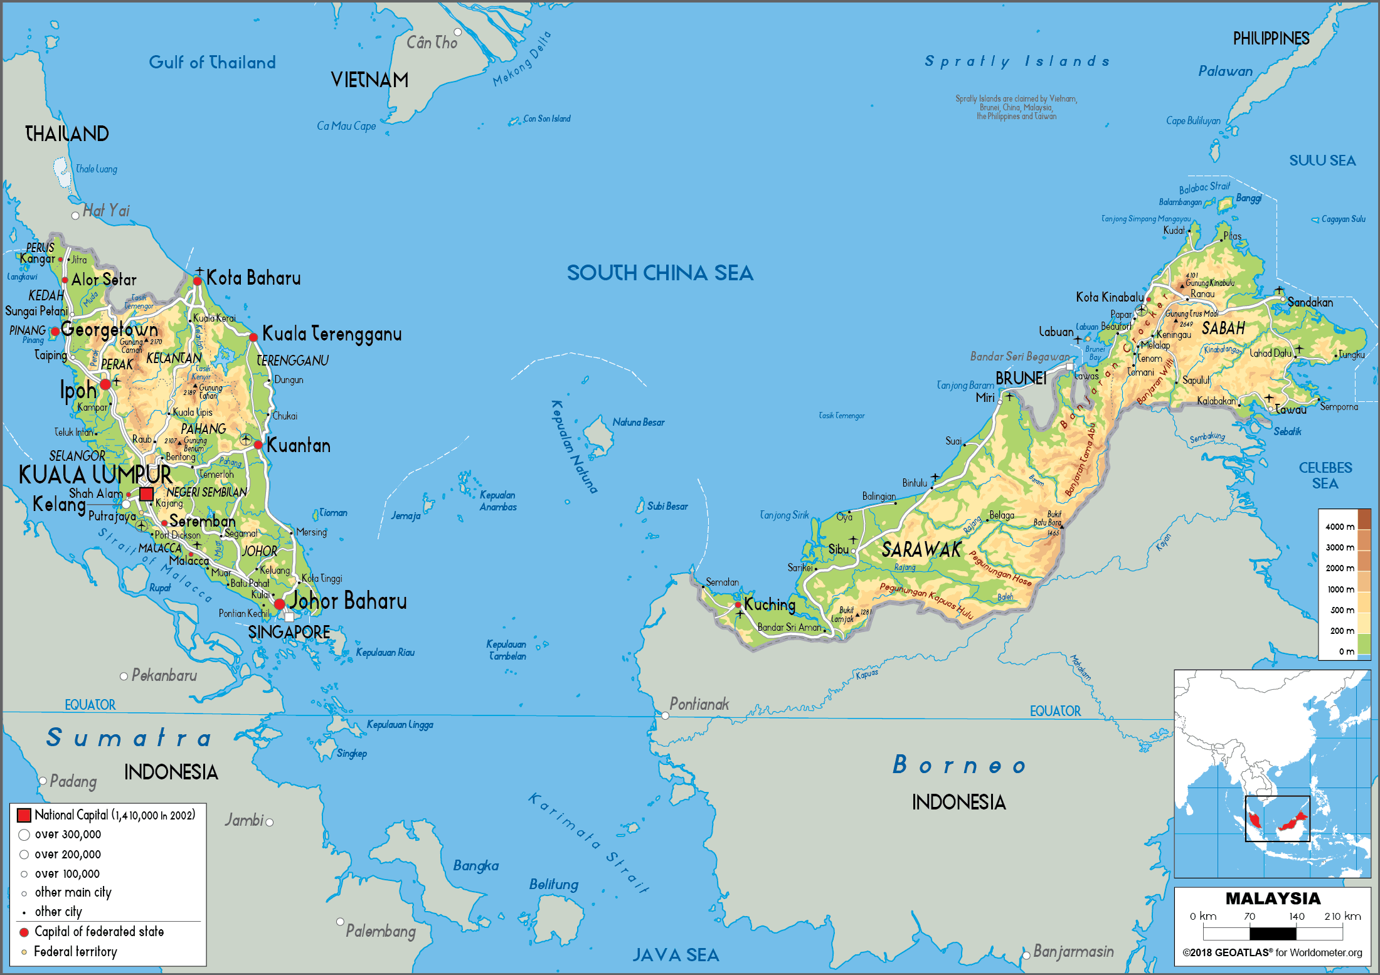

Figure 1: Map of Johor

Literature Review

The Implementation of Normal Land Conversion Application

For a standard application to change land use conditions, the landowner must fill out an application form at the District Land Office and pay the processing fee based on the type of change requested. The application form will be submitted for review by external technical departments. Once the land report is prepared by the Settlement Section, it will be forwarded to the District Land Administrator for initial approval. The application is then submitted to the State Land and Mines Office for final approval, which usually takes between six months and one year. Following approval by the State Land and Mines Office, the landowner will be issued a Notice 7G, which outlined the amount payable for land tax and other related fees. Upon completion of payment and receipt of the original land title, the applicant will fill out Form 7C to register the new title, either with the State Land and Mines Office (for Registrar title) or District Land Office (for District title).
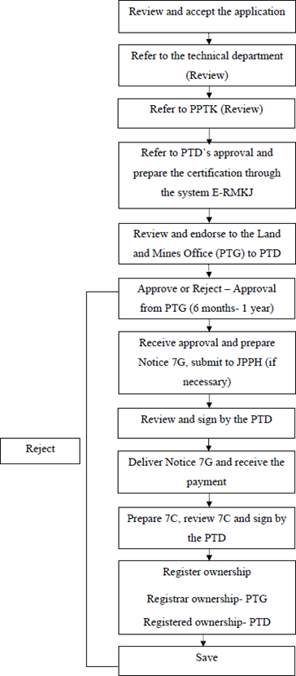
Figure 2: Normal Land Conversion Application (District Land Office)

The Implementation of ‘Fast Track’ Application

The ‘fast track’ land use condition change initiative in Johor was introduced to alleviate the burden of land tax payments following the tariff increase in 2020, particularly for land titles without specific land use conditions (NIL). This application is not applicable to titles that have defined land use conditions. Before making an application, the conditions that must be met include ensuring that the applicant is still alive and able to fulfil the affidavit. If the landowner has passed away, inheritance matters must be resolved first.

The authority to approve land use condition changes under Section 124 of the National Land Code 1965 lies with the State Authority, and the application must be submitted through the Pontian District Land Office. Applicants are required to fill out the provided land use condition change application form and attach all necessary supporting documents. The application form can be obtained from the District Land Office or downloaded from the State Land and Mines Office website. Before the application is processed, applicable fees must be paid, including a processing fee of RM1,300.00 and an application fee of RM60.00 for a change from NIL to an industrial land use condition change.

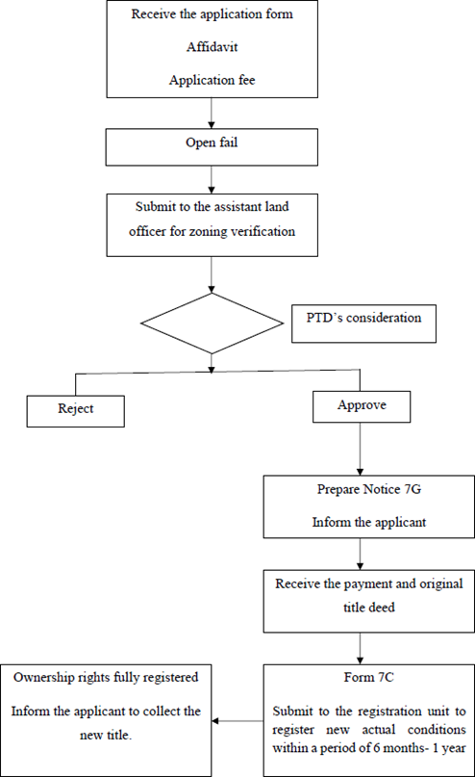
Figure 3: ‘Fast Track’ Land Conversion Application (District Land Office)

The Differences between Normal Land Conversion and ‘Fast Track’ Application

The differences between standard land use condition changes and ‘fast track’ changes in Johor significantly impact the land administration and development processes. A standard application for changing land use conditions involves a lengthy process, typically requiring six months to one year to obtain approval from the State Land and Mines Office (PTG). This process includes the inspection of land reports by technical departments and the appointment of Licensed Land Surveyors, which incurs additional costs for landowners. In contrast, the ‘fast track’ land use condition change allows applicants to obtain approval within one day from the District Land Administrator, thereby saving time and costs. This process does not require technical department inspections or the appointment of JTB and is only available to landowners with no specific land use conditions (NIL). The reduction in land tax rates after the implementation of the ‘fast track’ change is also an advantage offered, supporting landowners in paying higher land taxes after the tax increase in 2020. The comparison of these procedures clearly illustrates the distinctions between standard and ‘fast track’ land use condition, particularly from the applicant’s perspective. Based on these differences, it can be concluded that the ‘fast track’ procedure offers a more efficient and cost-effective alternative to the standard application process.

Table 1: Differences between normal land conversion and ‘fast track’ land conversion (Pontian District Land Office)

Normal Land Conversion | ‘Fast track’ Land Conversion
Requires endorsement from the Land and Mines Office | No endorsement or approval is required from the Land and Mines Office.
The approval process takes approximately six months to one year. | Approval is granted within one working day by the District Land Office.
Appointment of a Licensed Land Surveyor is mandatory | Appointment of a Licensed Land Surveyor is not required.
Land reports must be obtained from technical departments | There is no requirement to obtain reports or feedback from technical departments.
Higher land tax is imposed for land use conditions (NIL) | A lower land tax rate is applied based on the predetermined land use condition.

The literature review reveals the following key points regarding the ‘fast track’ application for changing land use conditions from NIL to a specified designation:
    - The objectives and application procedures differ between the standard land change process and ‘fast track’ approach. The application procedure for altering land use conditions is vital for guiding landowners and reducing breaches. Violations may result in property confiscation, as highlighted by Razani (2009) and supported by the findings of Aminah Mohsin et al., (2022).
    - The differences between the standard and 'fast-track' land use change processes can influence the development on land where the use condition is altered from "NIL" to another designation. These differences also affect the efficacy of the 'fast-track' process and the benefits it offers for landowners.

Research Methodology

Sabitha (2006) identifies research design as an important action plan to obtain detailed information. A well-defined research design prevents the research from deviating from its original objectives and goals. She further emphasises that the research results will depend on the chosen design and methods. This research design is also necessary to ensure that the required data can be collected to answer each research question. For this study, a qualitative research design, specifically, the interview method was adopted, based on the pre-determined research objectives. The methodology is structured into two phases, aligned with the objectives and subtopics, as shown in the diagram below.

Phase one outlines the methodology used to achieve the first objective of the study. It includes the formulation of the research objective, study’s scope, and assessment of the suitability of the chosen methodology. The literature review covers key definitions related to conventional and ‘fast track’ land use conversions, land taxation, and application procedures. It also highlights issues identified in past studies and sourced from secondary data. Data collection in this phase involved an extensive review of official documents and sources, such as the National Land Code 1965, relevant PTG Circulars, state land tax guidelines, and publications issued by the Department of the Director General of Lands and Mines.

Phase two employs a qualitative methodology, with data analysed descriptively. The qualitative approach involves collecting, analysing, and interpreting data based on individual’s observations of what individuals do and say (Basanta Kandel, 2020). In this phase, primary data was collected through interviews conducted with selected officers at the Pontian District Land Office, Johor. A semi-structured interview format was used, allowing respondents to elaborate on specific themes related to land use conversion procedures. Several key questions were posed to respondents regarding the application process for both ‘fast-track’ and conventional land use conversion, changes in land tax rates following the implementation of the fast-track system, and the differences between the two conversion methods. The respondents in this study were professionals from the Pontian District Land Office who possess in-depth knowledge and expertise in land use conversion process. As noted by Hamzah (2010), cited in Shaifuddin (2022), qualitative research requires a minimum of five respondents. In addition to the interviews, a SWOT analysis was conducted to assess the effectiveness of fast-track land use conversion implementation, particularly for cases with NIL-designated land use conditions. SWOT analysis has previously been employed to determine levels of effectiveness. For example, Samsul Abd. Rashid et al., (2020) utilised SWOT analysis to examine the E-Ease Order system from management and user perspectives, focusing on aspects of cost, quality, and time efficiency. The researchers used SWOT analysis to evaluate the system’s overall effectiveness in streamlining contract management processes.
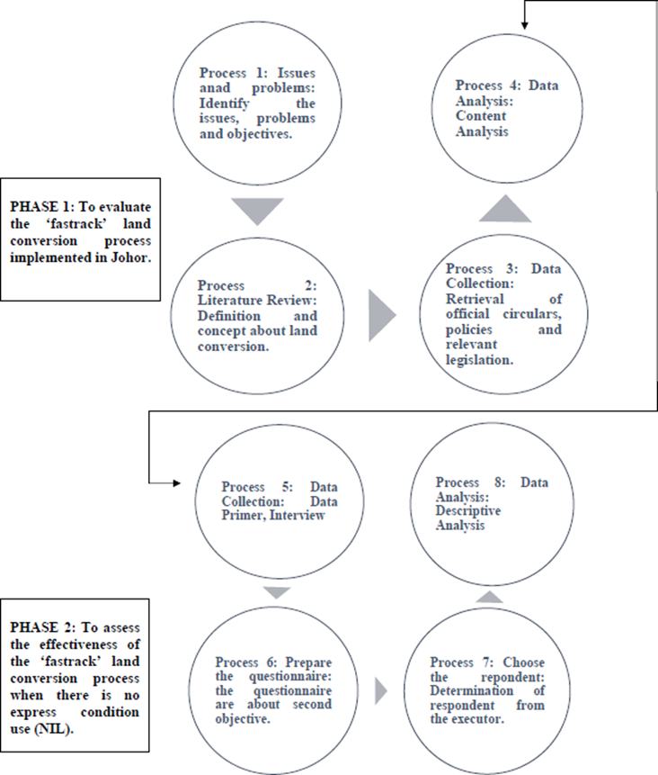
Figure 4: Research Methodology

Key and Result Analysis

Analysis of the Effectiveness of the 'Fastrack' Land Use Conversion Process for Land with No Specific Use (NIL)

The implementation process of fast-track land use conversion for cases where no express land use condition is stated has been carried out in the state of Johor., Its level of effectiveness has been discussed in the literature review of this study. This section analyses interview responses from five respondents from the Pontian District Land Office and incorporates their input into a SWOT analysis. These interviews reinforce the facts discussed in the literature review, particularly regarding implementing the ‘fast track’ land use condition change process. The objective is to assess the effectiveness of this process concerning land titles with no specific land use conditions (NIL), focusing on the secondary data collected. The researcher posed targeted questions to gather the respondents’ perspectives on the implementation, and their responses were subsequently categorised according to SWOT components: strengths, weaknesses, opportunities, and threats.

Strengths of the 'Fastrack' Land Use Conversion Process for Land with No Specific Use (NIL)

Based on the interviews, all five respondents (100%) stated that the main strength of the ‘fast-track’ land use conversion process for NIL land use conditions is the approval of applications within a single day, without requiring reviews from technical departments. This significantly increases state revenue, reduces administrative costs, and saves time. Additionally, 80% of the respondents (R1, R2, R3, and R5) believed that the exemption from appointing Licensed Land Surveyors is another major advantage, which helps reduce land tax arrears and eases the financial burden on landowners. Furthermore, R1, R4, and R5 highlighted that applicants only need to purchase a land search document costing RM60 (Pejabat Tanah dan Galian, 2022), an option that is both affordable and faster than obtaining an official copy of the title, thus making the application process more accessible and efficient.

Four respondents (R1, R2, R3, and R4) agreed that the first objective of the fast-track process, namely, to improve processing efficiency by securing approval from the District Land Office within a day, is effectively achieved. This is primarily due to the simplified process, which bypasses technical department reviews and does not require the appointment of a Licensed Land Surveyor. However, R5 noted that while the objective is generally met, it is conditional on the volume of applications. For instance, if 40 to 50 applications are received in a day, approvals may take up to approximately two days.

Regarding the second objective, to help reduce land tax rates for owners of land with NIL conditions, R1, R3, and R5 stated that it has been successfully achieved, particularly in the context of the 2020 land tax increase (Taklimat Pelaksanaan Cukai Tanah, PTG Johor). The tax increase prompted many landowners to use the fast-track process as a means to lower their tax burden. Similarly, R2 and R4 concurred, adding that NIL land use conditions typically incur higher tax rates compared to other categories such as agriculture, building, or industrial use. Another unanimously acknowledged strength is the potential of the fast-track process to reduce land tax arrears. All five respondents also agreed that the PTD’s acceptance and handling of fast-track applications are both efficient and user-friendly. Moreover, R1, R4, and R5 pointed out that the fast-track process helps minimise violations of land use conditions by encouraging landowners to update their land use to reflect actual usage.
Weaknesses of the 'Fastrack' Land Use Conversion Process for Land with No Specific Use (NIL)

Based on the interviews, all five respondents agreed that one of the main weaknesses of the ‘fast-track’ land use condition change process is the delay in registering the title after the application has been completed. If a property is subject to a mortgage or other restrictions imposed by banks, the application process may be further delayed. In such cases, the landowner must first resolve the matter with the bank and retrieve the original title, as all transactions conducted at the District Land Office require the original document (as stated by R2 and R5). Another weakness, highlighted by all five respondents, is the limited payment period for the issuance of Notice 7G in the fast-track process. The payment period is limited to one (1) month, compared to three (3) months in the standard land use condition change process. This reduced timeframe may lead to payment delays or cause landowners to cancel their applications due to difficulties in securing the required funds within the stipulated period. Furthermore, R2 pointed out that the opening period for fast-track applications is inconsistent, as it depends on circulars issued by the State Land and Mines Office. The lack of a fixed schedule may negatively affect state land tax revenue, particularly since land titles with NIL land use conditions are subject to higher tax rates compared to other land use categories, such as agriculture, residential, or industrial use (Adnan et al., 2019)

Threats of the 'Fastrack' Land Use Conversion Process for Land with No Specific Use (NIL)

The challenges or threats affecting the implementation of the ‘fast track’ land use condition change for NIL land use conditions, as reported by all five respondents, include difficulties encountered by implementers in providing adequate understanding of the process to applicants. R2 and R3 further noted that some staff at the District Land Office lack comprehensive knowledge of the ‘fast track’ land use condition change procedure, which hampers effective implementation. According to R5, another significant challenge arises when the landowners are deceased and the heirs attempt to apply for the fast-track land use change without first resolving inheritance matters. This often leads to the cancellation of the application following the issuance of Notice 7G. Additionally, R2 and R5 observed that some applicants fail to submit the required documents, neglect to update their current address, or miss the deadline for paying the Notice 7G fee, resulting in further delays. R2 and R4 also identified discrepancies in land use zoning as a common issue that may lead to the rejection of applications.

All respondents (R1, R2, R3, R4, and R5) agreed that although the fast-track process is designed to streamline land tax adjustments, only a small portion of the public applies for a reduction in land tax rates. According to records from the Pontian District Land Office, only two applications have been submitted to the Chief Minister for land tax reduction appeals, both of which remain under review, a process that is often time-consuming. Furthermore, R1, R3, and R5 mentioned additional issues such as applicants’ failure to pay current-year land taxes, submission of incomplete application forms, absence of consent letters from mortgagees, as well as unresolved caveats, leases, or rentals agreements, all of which hinder the application process.

Opportunities of the 'Fastrack' Land Use Conversion Process for Land with No Specific Use (NIL)

Several opportunities for improvement have been identified based on the implementation of the ‘fast track’ land use condition change process. According to all respondents, this implementation offers flexibility for public notary agencies and commissioners for oaths to set up service counters at each District Land Office and to establish title search counters at the State Land and Mines Office. This is particularly relevant because all ‘fast track’ land use condition change applications must be submitted through the District Land Office. R2 emphasised that the implementation of this process presents an opportunity to increase productivity within the land administration system. Additionally, R5 stated that applications for ‘fast track’ land use condition changes for NIL land use conditions do not require a fixed application period, offering further procedural flexibility. Therefore, based on the SWOT analysis conducted, the researcher is able to determine the effectiveness of the ‘fast track’ land use condition change process from the perspective of its implementers (Helms and Nixon, 2010).

Conclusions

Various issues have been examined regarding the implementation of the ‘fast track’ land use condition change for land titles with no specific land use conditions (NIL) in Johor. The study investigated the implementation process and assessed its effectiveness by analysing the strengths, weaknesses, opportunities, and threats associated with the initiative. The ‘fast track’ initiative aims to ease the financial burden on landowners by reducing land tax obligations and minimising land tax arrears, ultimately increasing state land tax revenue and improving the overall efficiency of the land administration system. The process demonstrates significant potential to enhance efficiency and reduce costs for landowners. Key strengths include the ability to obtain approval within one day without requiring reviews from technical departments and the exemption from appointing Licensed Land Surveyors. These features contribute to a faster, more cost-effective service for applicants. The objective of reducing land tax rates has been largely achieved. However, several challenges remain, including delays in title registration, issues with document handling, Notice 7G payments, limited understanding among District Land Office staff, and complications related to land inheritance. Despite these weaknesses and challenges, the findings from the SWOT analysis indicate that the ‘fast track’ implementation positively impacts landowners, enabling more efficient and effective land management practices.

Recommendations

To further enhance the effectiveness of the ‘fast track’ land use condition change process, several strategies are proposed:
- Expand of service access: Establish additional service counters involving public notary agencies and commissioners for oaths to facilitate more accessible and diversified service points.
- Staff training and awareness: Enhance training programmes for District Land Office staff to address knowledge gaps, particularly concerning land inheritance and supporting documentation.
- Process optimisation: Increase productivity by streamlining administrative workflows and incorporating digital solutions where feasible to reduce delays in title registration and document processing.
- Stakeholder communication enhancement: Improve communication channels with landowners and other stakeholders to clarify payment obligations, such as those related to Notice 7G, and ensure smoother and more transparent transactions.
These recommendations align with the opportunities identified in the SWOT analysis and aim to strengthen the initiative’s positive impact on landowners.

References

Adnan, M. Z., Samsudin, S., & Suratman, R. (2019). Land Tax Administration and Practice in Malaysia: A Review on Institutional and Governance Issues. International Graduate Conference of Built Environment and Survey, 1. Retrieved from https://www.researchgate.net/publication/335753107_Land_Tax_Administration_and_Practice_in_Malaysia_A_Review_on_Institutional_and_Governance_Issues

Ahmad Hamidi Mohamed, Noorfajri Ismail & Kamilah Wati Mohd. (2023). Kajian Kes Pertikaian Polisi Dan Perundangan Tanah Dalam Cadangan Pembangunan Tanah [Paper Presentation] The 4th International Conference of the Postgraduate Students and Academics in Syariah and Law, Universiti Sains Islam Malaysia.

Amirul Haffiz Ariff, Suhailizan Suliman, M.S.S & M.H.A. (2021). The Consideration of Zoning Compliance on the implementation of the Fastrack NIL in Johor. Journal of the Malaysian Institute of Planners, (19) (4), 12-22

Amir Al-Baihaqie (2020). Syarat Nyata Tanah dan Syarat Tersirat https://www.studocu.com/my/document/universiti-malaya/land-law-i/syarat-nyata-dan- tersirat/9767779

Chua Y. P. (2011). Kaedah dan Statistik Penyelidikan: Kaedah Penyelidikan. McGraw-Hill.

Ezahar Abu Sairan (2016, Jun). Percanggahan Kategori Guna Tanah di Daerah Kecil Labis. [Degree’s Thesis, Universiti Teknologi Malaysia, Malaysia]

Hamidi, M. A., & Musa, Y. (2019). Pertikaian Cadangan Pembangunan Tanah dan Syarat Nyata Tanah: Satu Kupasan. Jurnal Pentadbiran Tanah LAND, 3(1), 149–156.

Hamzah, A. (2010). Kaedah Kualitatif Dalam Penyelidikan Sosiobudaya. Jurnal Pengajian Media Malaysia. 6(1)

Ismail, N., Zakaria, S. R. A., & Samsudin, S. (2023). Konflik Pembangunan Lot Lidi dari Perspektif Perundangan Tanah. International Journal of Law, Government and Communication, 8 (32), 150-160.

Jabatan Audit Negara Malaysia. (2019, July 15). Laporan Ketua Audit Negara 2018. https://lkan.audit.gov.my/laporan/manage/28

Jansen D. & Warren K. (2020). What Is Research Methodology? GradCoach. https://gradcoach.com/what-is-research-methodology/

Jabatan Penilaian Dan Perkhidmatan Harta. (2022). Pengubahan Kategori Kegunaan Tanah. https://www.jpph.gov.my/v3/ms/perkhidmatan-jpph-2/aktiviti-penilaian-dan-perkhidmatan- harta/pengubahan-kategori-kegunaan-tanah/

Khairil Anwar Mohd Amin. (2019, August 15). Segerakan Urusan Ubahsyarat Tanah Pekebun Sawit. Sinar Harian. https://www.sinarharian.com.my/article/43093/berita/nasional/segerakan- urusan-ubah-syarat-tanah-pekebun-sawit

Lembaga Penyelidikan Undang-Undang. (2019) Kanun Tanah Negara 1965. Petaling Jaya. International Law Book Services.

Mohsen, M. (2022). A Kajian Permasalahan Tunggakan Cukai Taksiran di Majlis Perbandaran Kluang: Cukai Taksiran. Research in Management of Technology and Business, 3(1), 825-849.

M.Z. A Arif (2020, Januari). Tindakan Penguatkuasaan Terhadap Pelanggaran Syarat Tanah di Daerah Kuala Selangor. [Degree’s Thesis, Universiti Teknologi Malaysia, Malaysia]

